Startup Café Scenario
Let us imagine you are setting up a small café. You have raised ₹5,00,000 in seed funding and need to plan the budget and estimate costs over the first six months.
Assumptions:
- Monthly rent: ₹30,000
- Staff salaries (3 people @ ₹20,000 each): ₹60,000/month
- Inventory cost: ₹50 per cup of coffee
- Expected sales: 1000 cups/month at ₹100 each
- Marketing: ₹10,000/month
- One-time setup (furniture, equipment): ₹1,00,000
- Contingency: 10%

Step 1: Revenue Projections

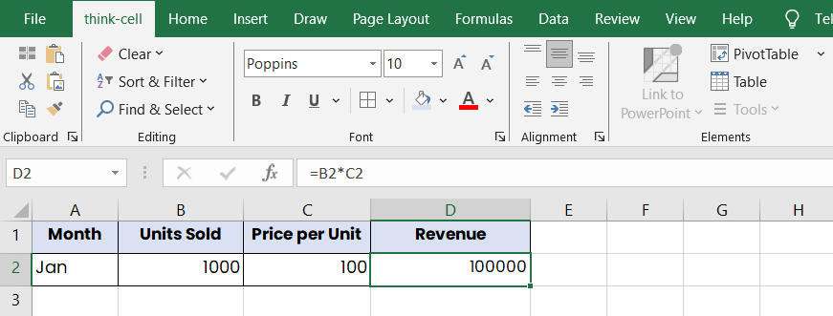

Step 2: Fixed Costs Table
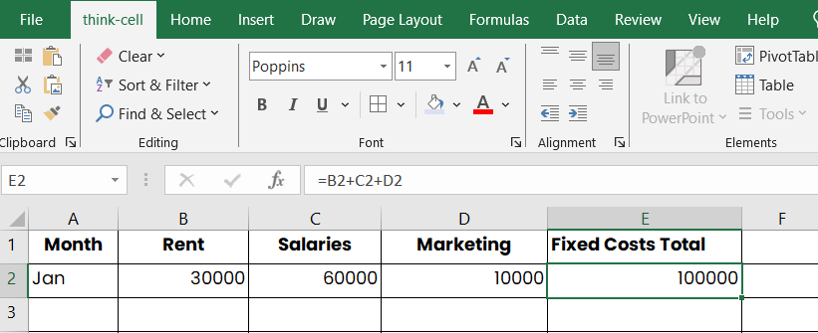
Step 3: Variable Costs
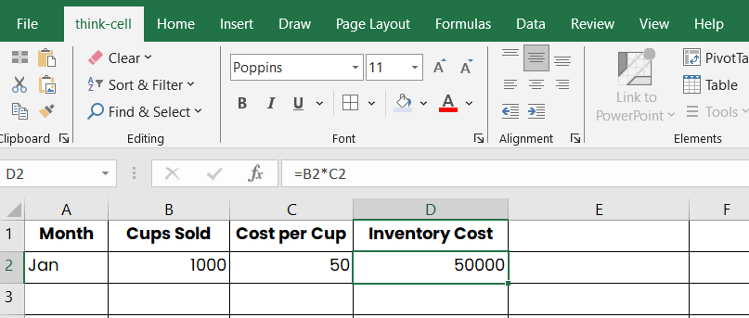
Step 4: One-Time Setup Costs
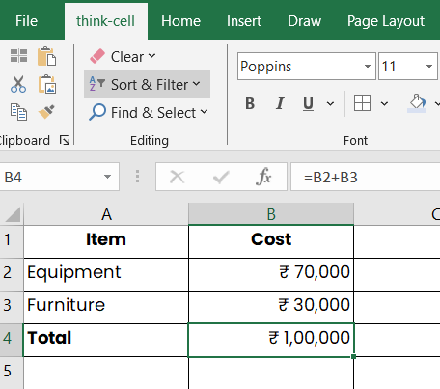
Step 5: Contingency
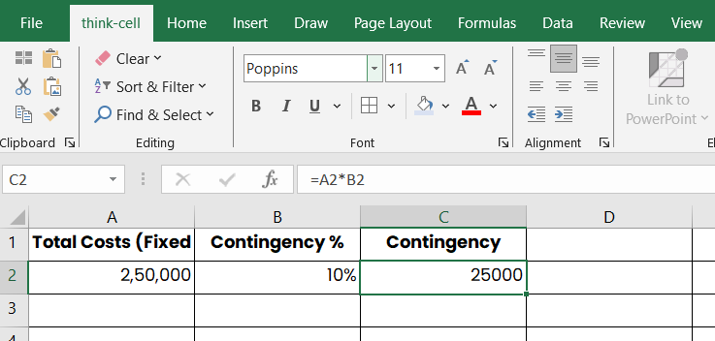
Step 6: Total Budget Overview
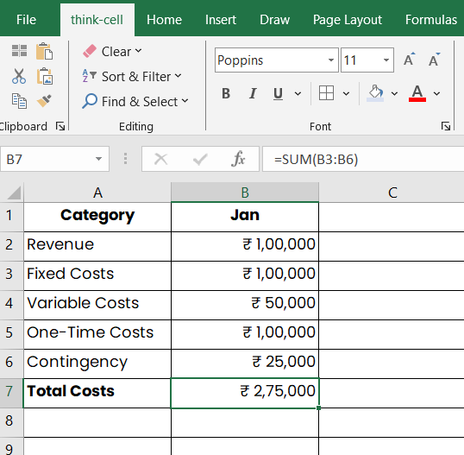
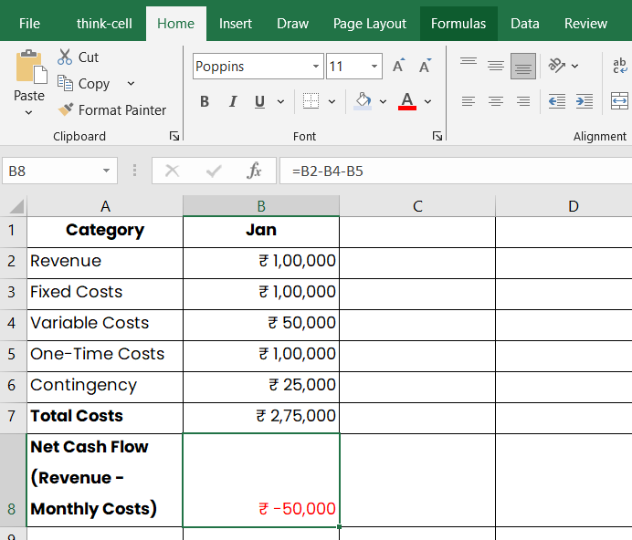
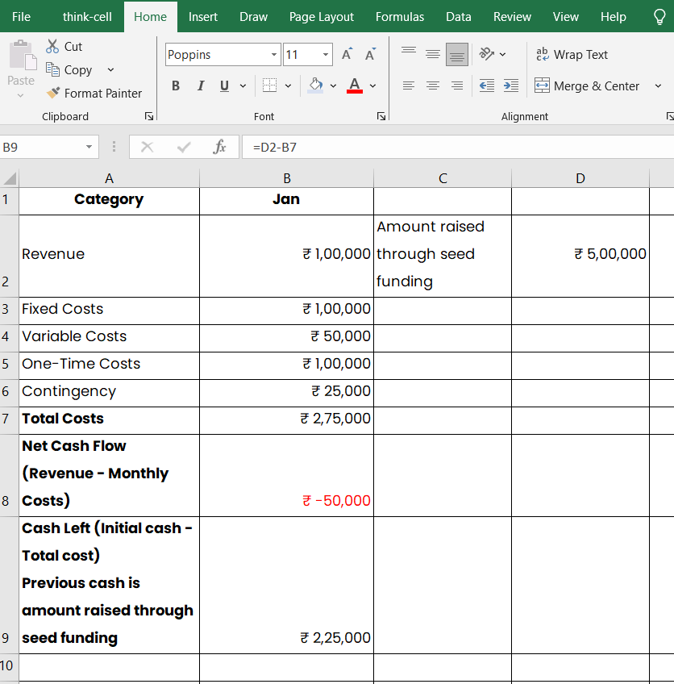
Step 7: Runway Calculation
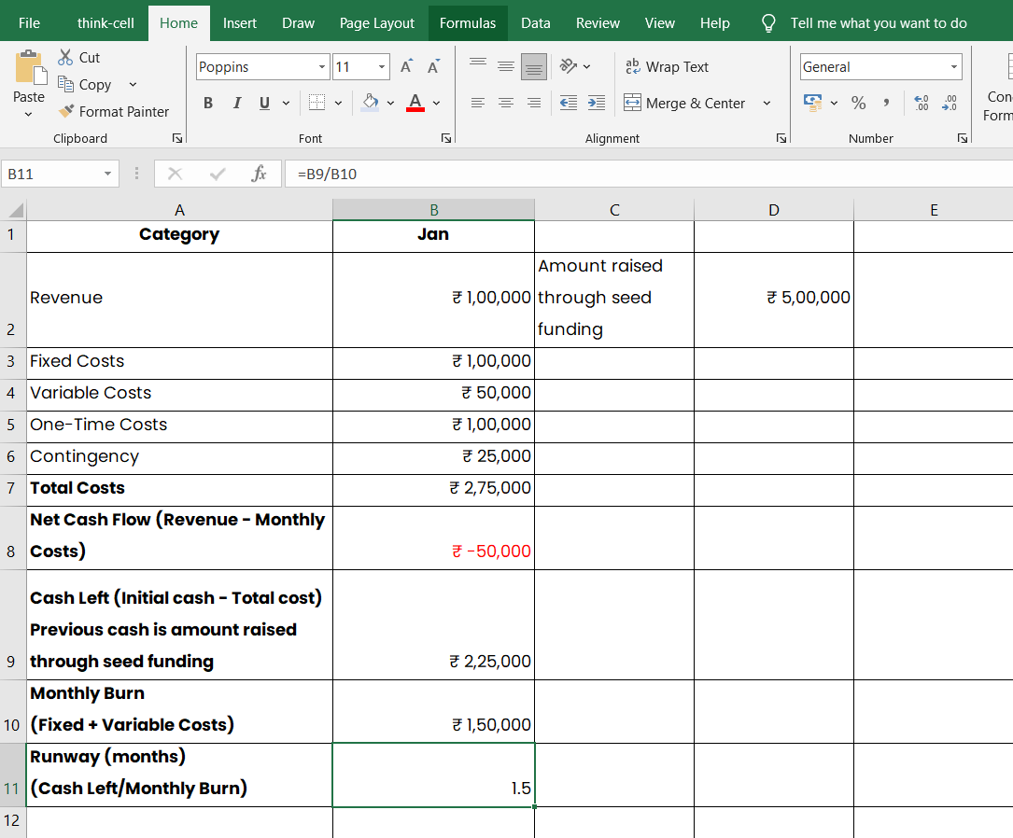

You can try them too on your Excel sheet for more clarity!

